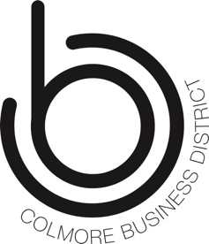

Community Games Application.

Company:
Team Name:

All physical activity of yourself and your group is undertaken at your own risk. By completing this application form you understand that there is a risk of injury associated with participating in physical activity.
You hereby assume full responsibility for any and all injuries, losses and damages that you, and your group, incur while attending, exercising or participating at Colmore BID’s Community Games 2023 event.. You hereby waive all claims against the Inspire Activity and Colmore Business District its volunteers, instructors, or partners or individually or otherwise, for any and all injuries, claims or damages that you might incur.

Team Member Details:

Name | DOB | Health Conditions | Sign

All team members will be required to supply there emergency contact details when checking in at the games.

Following receipt of application, we will supply payment options for the £40 per team fee, all team contributions go towards a charity donation.

